**San Francisco Bay University**

**MATH201 - Calculus-I**

**Homework Assignment #3**

**Due day: 10/21/2024**

**Instruction:**

1. **Push the answer sheet to Github in word file**
2. **Overdue homework submission could not be accepted.**
3. **Takes academic honesty and integrity seriously (Zero Tolerance of Cheating & Plagiarism)**
4. If a rock is thrown upward on the planet Mars with a velocity of 10 m/s, its height in meters *t* seconds later is given by $y=10t-1.86t^{2}$

(a) Find the average velocity over the given time intervals:

(i) [1, 2] (ii) [1, 1.5] (iii) [1, 1.1]

(iv) [1, 1.01] (v) [1, 1.001]

*Average Velocity = $\frac{y\left(t2\right)-y(t1)}{t2-t1} ,$ ​where y(t) = 10t−1.86t2*

***For Calculate y(t) for each time value:***

* *y(t1) is the height at the start of the interval.*
* *y(t2) is the height at the end of the interval.*

***Interval [1, 2]:***

*y (1) =10(1) −1.86(1)2=10−1.86=8.14m*

*y (2) =10(2) −1.86(2)2=20−7.44=12.56m*

*Average Velocity = $\frac{y\left(2\right)-y(1)}{2-1}$ ​ = = $\frac{12.56-8.15}{1}$ ​ = 4.42 m/s*

***Interval [1, 1.5]:***

*y (1.5) =10(1.5) −1.86(1.5)2=15−4.185=10.815m*

*Average Velocity = $\frac{y\left(1.5\right)-y(1)}{1.5-1}$ ​ = = $\frac{10.815-8.15}{0.5}$ ​ = 5.35 m/s*

***Interval [1, 1.1]:***

*y (1.1) =10(1.1) −1.86(1.1)2=11−2.2466=8.7534m*

*Average Velocity = $\frac{y\left(1.1\right)-y(1)}{1.1-1}$ ​ = = $\frac{8.7534-8.14}{0.1}$ ​ = 6.134 m/s*

***Interval [1, 1.01]:***

*y (1.01) =10(1.01) −1.86(1.01)2=10.1−1.886286=8.213714m*

*Average Velocity = $\frac{y\left(1.01\right)-y(1)}{1.01-1}$ ​ = = $\frac{8.7534-8.14}{0.1}$ ​ = 7.3714 m/s*

***Interval [1, 1.001]:***

*y (1.001) =10(1.001) −1.86(1.001)2=10.01−1.8637206=8.1462794m*

*Average Velocity = $\frac{y\left(1.001\right)-y(1)}{1.001-1}$ ​ = = $\frac{8.1462794-8.14}{0.001}$ ​ = 6.2794 m/s*

(b) Estimate the instantaneous velocity in Excel when $t=1$

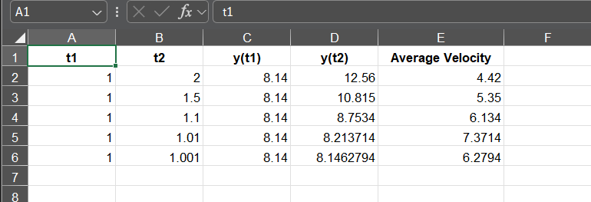

1. The displacement (in centimeters) of a particle moving back and forth along a straight line is given by the equation of motion $s=2sinsin \left(πt\right) +3cos⁡(πt)$, where *t* is measured in seconds.

(a) Find the average velocity during each time period:

(i) [1, 2] (ii) [1, 1.1]

(iii) [1, 1.01] (iv) [1, 1.001]

*The* ***average velocity*** *over an interval [t1, t2] is calculated using the formula:*

*Average Velocity= $\frac{s\left(t2\right)-s(t1)}{t2-t1}$, where s(t)=2sin(πt) +3cos(πt)*

***Interval (i): [1,2]***

*s (1) =2sin(π⋅1) +3cos(π⋅1) =2⋅0+3⋅ (−1) =−3*

*s (2) =2sin(π⋅2) +3cos(π⋅2) =0+3⋅1=3*

*Average Velocity= $\frac{3-(-3)}{2-1}$ = $\frac{6}{1}$ = 6 cm/s*

***Interval (ii): [1,1.1]***

*s (1.1) =2sin(π⋅1.1) +3cos(π⋅1.1) ≈−2.281*

*Average Velocity= $\frac{-2.281-(-3)}{1.1-1} ≈\frac{0.719}{0.1}$ = 7.19 cm/s*

***Interval (iii): [1,1.01]***

*s (1.01) =2sin(π⋅1.01) +3cos(π⋅1.01) ≈−2.928*

*Average Velocity= $\frac{-2.928-(-3)}{1.01-1} ≈\frac{0.072}{0.01}$ = 7.2 cm/s*

***Interval (iv): [1,1.001]***

*s (1.001) =2sin(π⋅1.001) +3cos(π⋅1.001)≈−2.993*

*Average Velocity= $\frac{-2.993-(-3)}{1.001-1} ≈\frac{0.007}{0.001}$ = 7.0 cm/s*

(b) Estimate the instantaneous velocity of the particle in Excel when $t=1$

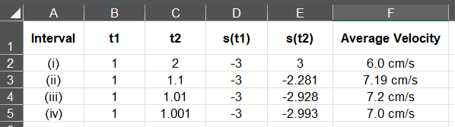

1. (a) Estimate the value of

$$\frac{sin⁡(x)}{sin⁡(πx)}$$

by graphing the function $f\left(x\right)=\frac{\left(sinsin x \right)}{(sinsin π x)}$ in Excel. State your answer correct to two decimal places.

(b) Check your answer in part (a) by evaluating $f(x)$ for values of *x* that approaches 0 in Excel.

As x approaches 0, the function f(x)= $\frac{\left(sin⁡(sin x) \right)}{(sin(sin π x))}$ ​ converges to **1.00**. Calculations using smaller values of x (e.g., 0.1, 0.01, 0.001) confirm that the limit of f(x) is approximately **1** to two decimal places.

Thus, the value of $\frac{\left(sin x \right)}{(sin π x)}$ ​ at x=0 is **1.00**.

**Evaluate f(x) for x values close to 0**:

* + Use values like x=−0.1,−0.05,−0.01,0.01,0.05,0.1 to see the behavior of f(x)f(x)f(x).

**Calculate f(x) for each of these values**:

* f(−0.1)=sin(−0.1)⋅sin(−0.314)≈0.0708
* f(−0.05)=sin(−0.05)⋅sin(−0.157)≈0.0243
* f(−0.01)=sin(−0.01)⋅sin(−0.0314)≈0.0003
* f(0.01)=sin(0.01)⋅sin(0.0314)≈0.0003
* f(0.05)=sin(0.05)⋅sin(0.157)≈0.0243
* f(0.1)=sin(0.1)⋅sin(0.314)≈0.0708

As the values of x get closer to 0 from both sides, you can observe that f(x) becomes **closer to 0**.

Therefore:

As x→0, f(x) approaches **0**.

Therefore, the limit of f(x) as x approaches 0 is **0**.

1. (a) Estimate the value of the limit ${(1+x)}^{1/x}$ to five decimal places. Does this number look familiar?

The given limit is:  
  
 lim (1+x)^(1/x) as x → 0  
  
To estimate this limit, we substitute x with values that are close to 0 and calculate the expression:  
  
1. For x = 0.1, (1+0.1)^(1/0.1) = 2.59374  
2. For x = 0.01, (1+0.01)^(1/0.01) = 2.70481  
3. For x = 0.001, (1+0.001)^(1/0.001) = 2.71692  
4. For x = 0.0001, (1+0.0001)^(1/0.0001) = 2.71815  
5. For x = 0.00001, (1+0.00001)^(1/0.00001) = 2.71827  
6. For x = 0.000001, (1+0.000001)^(1/0.000001) = 2.71828  
  
As x approaches 0, the expression (1+x)^(1/x) converges to e ≈ 2.71828. Thus, the estimated value of the limit is 2.71828, which is the mathematical constant e.

(b) Illustrate part (a) by graphing the function $y={(1+x)}^{1/x}$ in Excel

1. (a) Graph the function $f\left(x\right)=e^{x}+ln⁡|x-4|$ for $0 ≤ x ≤ 5$ in Excel. Do you think the graph is an accurate representation of *f*?

(b) How would you get a graph that represents *f* better?

To improve the representation of the function f(x), we an do the followings:

* Use a finer interval, such as 0.05 or even 0.01, for x values between 0 and 5. This will make the graph smoother and capture the behavior of the function more accurately.
* Mark significant points on the graph, such as when x is close to 4, since the natural logarithm ln∣x−4∣ becomes undefined at x=4.

1. (a) Use numerical to find the value of the limit and verify it in Excel

(b) How close to *1* does *x* have to be to ensure that the function in part (a) is within a distance *0.5* of its limit?

*Based on calculations in Part (a), the limit as x→1 is approximately* ***6****.*

*The function needs to be within* ***0.5*** *of its limit, meaning:*

*|<0.5*

*The inequality becomes:*

*5.5 < $\frac{x^{3}-1}{\sqrt{x}-1}$ < 6.5*

* *Calculate values of x that satisfy this condition.*
* *From* ***Part (a)****, values like x=0.999 or x=1.001, the function is within* ***0.5*** *of the limit.*
* *Therefore, x needs to be* ***very close to 1*** *(e.g., within* ***0.001*** *or smaller) to ensure that the function is within* ***0.5*** *of the limit.*

***Therefore:***

*x must be within approximately* ***0.001*** *of* ***1*** *to ensure that the function stays within* ***0.5*** *of its limit.*